On behalf of the PGA TOUR, I wish all of our fans in China a Happy New Year. We are very pleased to be entering the second year of our partnership with SINA.

We are excited about the upcoming 2009 season for a number of reasons. First, we will witness Tiger Woods’ return to the game after a lengthy absence recovering from knee surgery. His return will be the biggest story in sports and it will be interesting to see how he performs and the reaction of his competitors to him being back.

During Tiger’s absence, new stars emerged performing well on golf’s biggest stages. Anthony Kim won twice, earning victories against strong competition in the Wachovia Championship and the AT&T National. Sergio Garcia won THE PLAYERS for his biggest victory to date, and then performed superbly in the PGA TOUR Playoffs for the FedExCup losing in playoffs twice.

Speaking of the PGA TOUR Playoffs for the FedExCup, Camillo Villegas earned his elusive first victory in the BMW Championship and then followed it immediately with a win THE TOUR Championship presented by Coca-Cola in the next tournament.

Players like Boo Weekley captured the imagination of fans with his performance and his personality. Both of these were prominently on display at the Ryder Cup as he helped the United States to victory.

Padraig Harrington won consecutive majors at the British Open and PGA Championship and was honored by his fellow players as the PGA TOUR Player of the Year.

The FedExCup enters its third year in 2009 and we are excited about the changes that we made to it. With these changes, it is more important than ever to play well during the regular season to be positioned to succeed in the playoffs. Good play in the Playoff events will be essential because the better a player’s standing entering THE TOUR Championship presented by Coca-Cola, the better his chances will be to win the FedExCup. Every player at THE TOUR Championship will have a mathematical chance to win the FedExCup, with the highest seeds having the best chances.

These changes will maintain emphasis on regular season performance, while ensuring an exciting Playoffs and providing drama that culminates at THE TOUR Championship.

I wish you and yours a successful and happy new year. Enjoy the 2009 PGA TOUR season.

Sincerely,

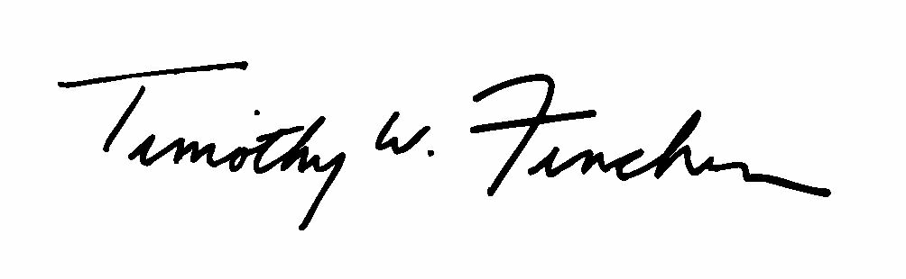
Timothy W. Finchem

