2009 HSBC China Junior Golf Open
Tournament Terms & Conditions

- Tournament Name: HSBC China Junior Golf Open
- Tournament Host: China Golf Association
- Co-Host: General Administration of Sports Multi-ball Sports Centre
- Promoter: Guangdong Golf Association; IMG
- Title Sponsor: Hong Kong and Shanghai Banking Corporation
- Program Partner: TaylorMade adidas Golf; The R & A
- Supplier: 5100 Tibetan Spring Glacier
- Tournament Date: 18 - 23 January 2009
- Tournament Location: Guangdong Nansha Golf Club
- Tournament Format：Individual stroke play (boys and girls)
- Application Criteria and Groupings
1. Chinese Nationals: Junior players (boys & girls) between the ages of 6 year-old (including 6 year-old) and 17 year-old (including 17 year-old) of Chinese National (excluding Hong Kong, Macau and Taiwan)
Foreign Players: Junior players (boys & girls) between the ages of 11 year-old (including 11 year-old) and 17 year-old (including 17 year-old)
2. Applicants must be of the following age (Beijing time) before the tournament：
Group A：15-17 years old (date of birth between 1991 Jan 23 and 1994 Jan 22)
Group B：13-14 years old (date of birth between 1994 Jan 23 and 1996 Jan 22)
Group C：11-12 years old (date of birth between 1996 Jan 23 and 1998 Jan 22)
Group D：9-10 years old (date of birth between 1998 Jan 23 and 2000 Jan 22)
Group E：8 years old and below (date of birth between 2000 Jan 23 and 2003 Jan 22)

- Tournament Format
1. Groups A, B, C will play 54 holes while Groups D & E will play 36 holes stroke play, players with the least stroke will be the winner. In the event of a tie for 1st place, the players will go into a sudden-death playoff to decide the winner. When there is a tie from runners up to 8th position, the tournament committee will use the count back system to decide the player’s position and if there is still a tie, a draw will decide the player’s position.
2. Group A players will have to carry their own golf bag for the tournament; Group B & C players may choose to carry their own golf bag or pull cart for the tournament. Groups A, B, C will be provided with 1 scoring caddie; service caddies will be provided to each player in Groups D & E.
3. Tournament dress code: All local Chinese players must wear T-shirts, apparels, caps and umbrellas provided by the organizing committee. All players are to provide their own golf shoes and golf equipments.
4. Tee boxes used by groups:
Blue Tee: Groups A & B Boys
White Tee: Group C Boys and Groups A & B Girls
Red Tee: Group D Boys and Groups C & D Girls
Special Tee: Groups E, Boys and Girls
5. Any particular group with less than 6 players, that particular group tournament will be cancelled.

13. Tournament Rules
The tournament will use golf rules from The Rules of Golf (2008 version) from the R&A and players are to abide to the local rules set by the tournament committee

14. Rankings and Awards:
- Awards each group’s top 8 players with certificate and top 3 players with prizes.
- This tournament will also include a team event vying for team top 3 positions with no limitation to age group or gender. The lowest 4 scores from each country with their aggregate 3-day total scores will count towards their team score and the lowest score will win the team event. Any country with less than 4 players will not be eligible to enter for the team event.
- An award for “Sports Best Etiquette” will be awarded to 4 players.
- Tournament committee will not set a hole-in-one prize but the host golf club may have a prize for any hole-in-one achieved.
- When the number of players from any groups with less than 8 players (including 8), awards will be given to all players within that group except for the last 2 positioned players.
- When the number of players for any group is less than 15 players, ranking points will be given to all within that group except for the last 2 positioned players.

15. Tournament Application and Registration
1. All participants are to fill-in an application form and must be signed by a parent or guardian. All applications must be faxed to China Golf Association at 86-10-87182908 (Tel: 86-10-87182809). Deadline for application: 2008 December 21. Late applicants will not be entertained. The organizing committee will purchase accident insurance for all players, insuring period will be from 2009 January 15th till 2009 January 24th.
2. Local Chinese players’ limitation:
Group A – Maximum at 20 players;
Group B – Maximum at 25 players;
Group C – Maximum at 25 players;
Group D – Maximum at 20 players;
Group E – Maximum at 15 players;
International players’ limitation: 6 players per country (including boys and girls)
Local Chinese players will be limited to 105 players
Application consideration will be based on 2008 year-end and junior final ranking. Once the number of applicant reaches the maximum, China Golf Association will stop further application. For the safety and smooth running of the tournament, China Golf Association will reserve the right to limit the number of players at the tournament.
3. Based on the HSBC Ranking System published by the China Golf Association, top-ten ranked players of each group will be given preference to enter in the tournament
4. At registration, all players must produce their valid original identification documents with them (Personal ID Card, Passport or Residential book), otherwise, entry will be denied.
5. Registration date, time:
For Groups D & E: 18 January 2009 – 07:00 – 09:30
For Groups A, B, C: 20 January 2009 – 07:00 – 09:30
Location: Guangzhou Nansha Golf Club clubhouse.
6. We would like to invite all players to visit our website at: golf.org.cn/youth/ or golf.sina.com.cn to download application forms and obtain tournament information.
7. After the closing date, no players will be allowed to change groupings.
8. During the tournament, NO parents or coaches will be permitted onto the golf course.

16. Tournament Committee
Tournament committee reserves the right to change the tournament start time and the rules of play.

17. Player Reception

Recommended hotel: Nanshan World Trade Center Apartment Hotel
Hotel Reservation Number：86(20)28661388(hotel reservation desk)
Address:156 Gangqian Avenue South, Nanshan, Guangzhou
Rates ： RMB 350 for Single Room
RMB 550 for two bedrooms
RMB 850 for 3 bedrooms
Note: All rooms are apartments including living room.

Golf course: Guangzhou Nansha Golf Club
Address：Guangzhou Nansha Economic Zone, Lu Wan Area, China
Contact No.：020-84681888 (golf reservation desk)
Fax：020-84680728

18. Daily Schedule：
Day | Date | Schedule of Events
Day 1 | 18 Jan 09 | Groups D & E Players Registration, Meeting and Practice Round
Day 2 | 19 Jan 09 | Groups D & E Round one of tournament
Day 3 | 20 Jan 09 | Groups D & E Final round of tournament
Day 3 | 20 Jan 09 | Groups A, B, C Players Registration, Meeting and Practice Round
Day 3 | 20 Jan 09 | Groups D & E Prize Presentation and Gala Dinner
Day 4 | 21 Jan 09 | Groups A, B, C Round 1 of tournament
Day 5 | 22 Jan 09 | Groups A, B, C Round 2 of tournament
Day 6 | 23 Jan 09 | Groups A, B, C Final Round with Prize Presentation

19. Tournament Entry Fee:
- International player’s entry fee: USD220 per person includes daily lunch at the golf club and one dinner at the welcome reception. All travelling and accommodation cost are to be borne by themselves.
- Local Chinese players will bear their own travel and accommodation cost.
- China Golf Association will bear all cost for the welcome dinner, all golfing cost including practice round and tournament rounds.

20. Rules Official and Staffing
China Golf Association will provide all rules officials and staffing for the tournament.
21. China Golf Association will reserve the rights on all interpretation of the above.

交通信息
Transportation Information
深圳-南沙 (Shenzhen Airport – Nansha)
从深圳宝安机场----------南沙区南沙高尔夫球会的路线图
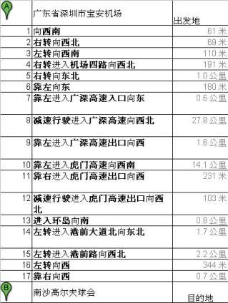
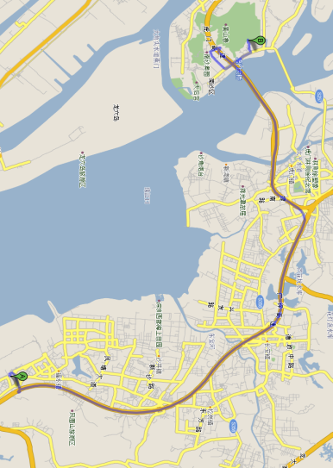

广州-南沙 (Guangzhou Airport – Nansha)

从广州白云机场---------南沙区南沙高尔夫球会的路线图
